Outlook 2016 Quick Start

With Outlook on your PC, Mac or mobile device, you can:
- Organize email to let you focus on the messages that matter most.
- Manage your calendar to schedule meetings and appointments with ease.
- Share files from the cloud so recipients always have the latest version.
- Stay connected and productive wherever you are.
Add an email account
- Open Outlook. If you haven't launched Outlook before, you'll see a welcome screen. Otherwise, choose File > Add Account.
- Enter your email address, then select Connector, if your screen looks different, enter your name, email address, and password, and then select Next.
- If prompted, enter your password and select OK.
- That's it. Select Finish to start using Outlook 2016.
Note: If you're having trouble setting up your email or need manual setup steps, see Troubleshooting Outlook email setup.
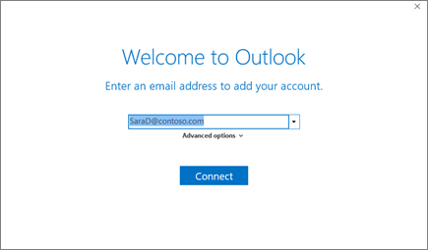
Create and send email
- Choose New Email to start a new message.
- Enter a name or email address in the To..., Cc, or Bcc field.
Tip: If you don't see Bcc, see Show, hide, and view the Bcc box.
- In Subject, type the subject of the email message.
- Place the cursor in the body of the email message, and then start typing.
- After typing your message, choose Send.
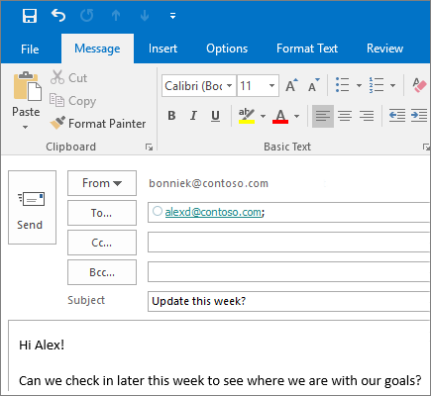
Use @mentions to get someone's attention
- In the body of the email message or calendar invite, enter the @ symbol and the first few letters of the contact's first or last name.
- When Outlook offers you one or more suggestions, choose the contact you want to mention.
By default, their full name is included. You can delete a portion of the mention, for example, everything other than the person's first name.
- The mentioned contact is added to the To line of the email or the meeting invite.
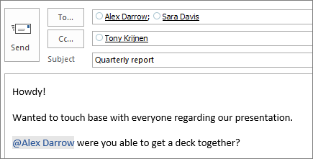
Focused Inbox
Focused Inbox helps you focus on the emails that matter most. It separates your inbox into two tabs—Focused and Other.
If messages aren't organized the way you want, you can move them and specify where all future messages from that sender should be delivered.
- From your inbox, choose the Focused or Othertab, and then right-click the message you want to move.
- If moving from Focused to Other, choose Move to Other if you want only the selected message moved. Choose Always Move to Other if you want all future messages from the sender to be delivered to the Other tab.
If moving from Other to Focused, choose Move to Focused if you want only the selected message moved. Choose Always Move to Focused if you want all future messages from the sender to be delivered to the Focused tab.
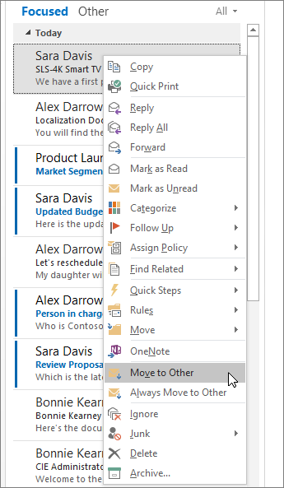
Schedule an appointment
- In Calendar, choose New Appointment.
- In the Subject box, type a description.
- In the Location box, type the location.
- Enter the start and end times.
- Choose Invite Attendees to turn the appointment into a meeting.
- Chose Save & Close to finish or Send if it's a meeting.
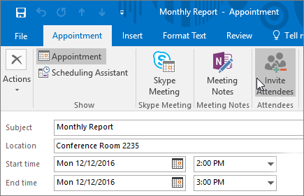
Use the Scheduling Assistant
The Scheduling Assistant tool appears after you create a meeting and helps you find the best time for your meeting by analyzing when recipients and meeting resources, such as rooms, are available.
- From a new meeting request, choose Scheduling Assistant.
- Vertical bars surrounding a shaded area represent the current time of the meeting. You can drag the bars to adjust the meeting time.
- The grid shows attendee availability. Along the right side of the meeting request, Outlook shows you suggested times to meet, along with the number of conflicts your attendees have.
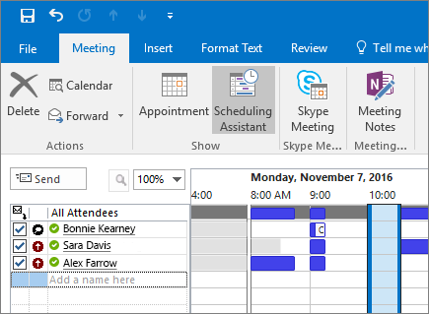
Add a contact
- Choose People.
- Choose Home > New Contact or press Ctrl+N.
- Enter a name and any other information that you want to include for the contact.
- Choose Save & New if you want to create another contact or Save & Close if you are done.
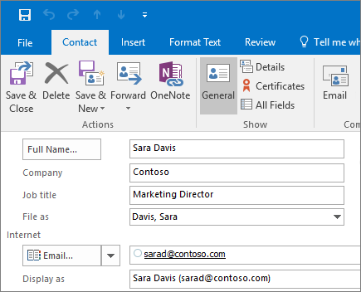
Share a file to collaborate on attachments
- Create a message or Reply To, Reply All or Forward an existing message.
- Choose Attach File.
- Choose a file from the list of recent files you've worked with.
- If the file shows a small cloud icon, the file is saved online and you will share the file.
If the file does not show a cloud, choose the small arrow and choose Upload to OneDrive.
Note: To change permissions for shared files, see Manage the items attached to an email.
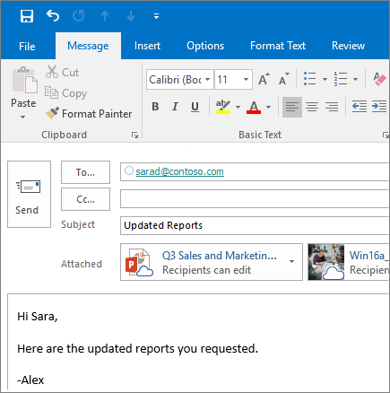
Smarter meetings with Skype and OneNote
Outlook helps you schedule meetings with other people, but you can also create an online meeting and set up a shared space for meetings notes before you send your meeting request.
Once you've added attendees to your meeting, select the Skype Meeting button on the ribbon. An online meeting will be created automatically, and a link inserted into the meeting request.
For shared notes, select the Meeting Notes button. You can create a new OneNote notebook or select an existing notebook. A link to the notebook will appear in the meeting request.
